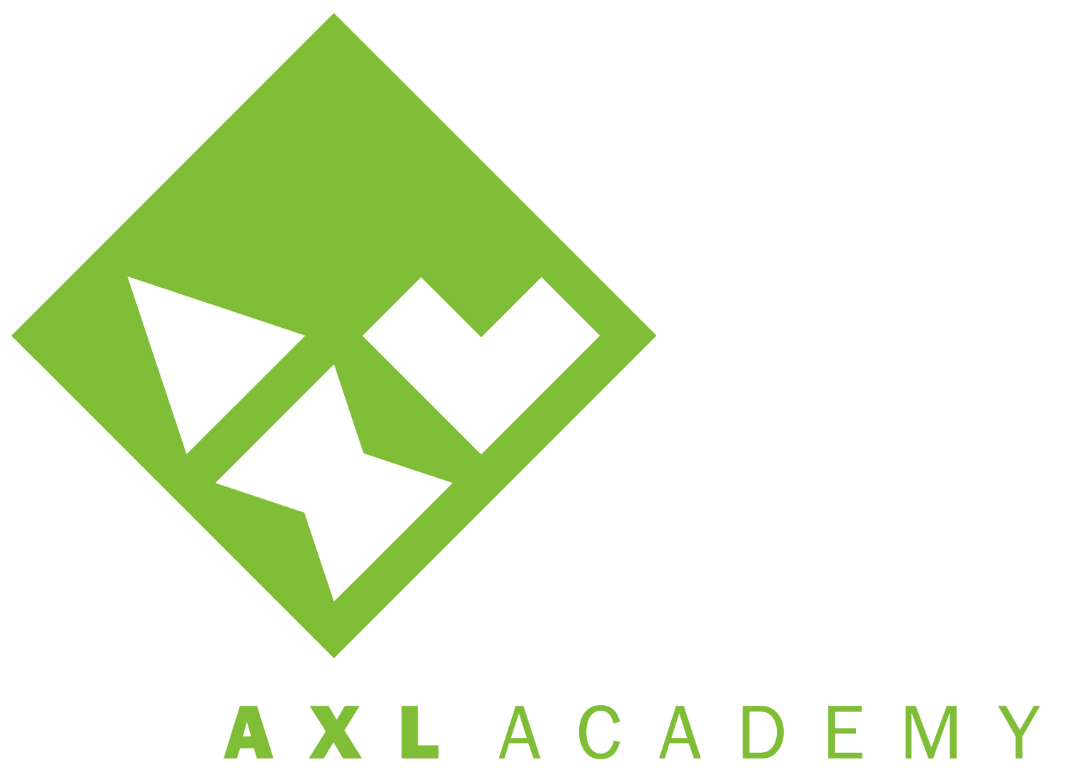
BOARD OF DIRECTORS AGENDA
Friday, October 25, 2013
8:00am – 10:00am
AXL Academy

- Preliminary (5 min)
- Roll Call/Declaration of Quorum
- Approval of Agenda
- Approval of Minutes
- Public Comment

- Business Agenda (30 min)
- Actuals v FY14 Operating Budget – 5 min (Pete Piccolo)
- FY13 Final Audit Report – 5 min (Audra Philippon)
- Development Committee Updates – 10 min (Jennie Fuge)
- Head of School Report – 5 min (Audra Philippon)

- Discussion (75 min)
- Formation of Facilities Committee – 30 min (Ray Baker & Audra Philippon)
Goals, membership, meetings, Fall 2014 expansion, capital financing
- Next Steps with APS – 15 min (Pete Piccolo)
- Elevator Pitch Practice – 25 min (Lindsey Crum)
- Accountability Committee, Draft UIP 2013-14 – 5 min (Audra Philippon)

- Action Items (5 min)
- Proposed Revised FY14 Operating Budget (Audra Philippon)
- Contingency Budget for APS (Matt Wasserman)

- Executive Session (5 min)

- Topics for Next Meeting
- Head of School’s Performance Evaluation (Audra Philippon)
- Election of Board Officers, Committee Membership (Pete Piccolo)

- Adjournment

Next Meeting: November 22, 2013
8:00am – 10:00am
at AXL Academy

