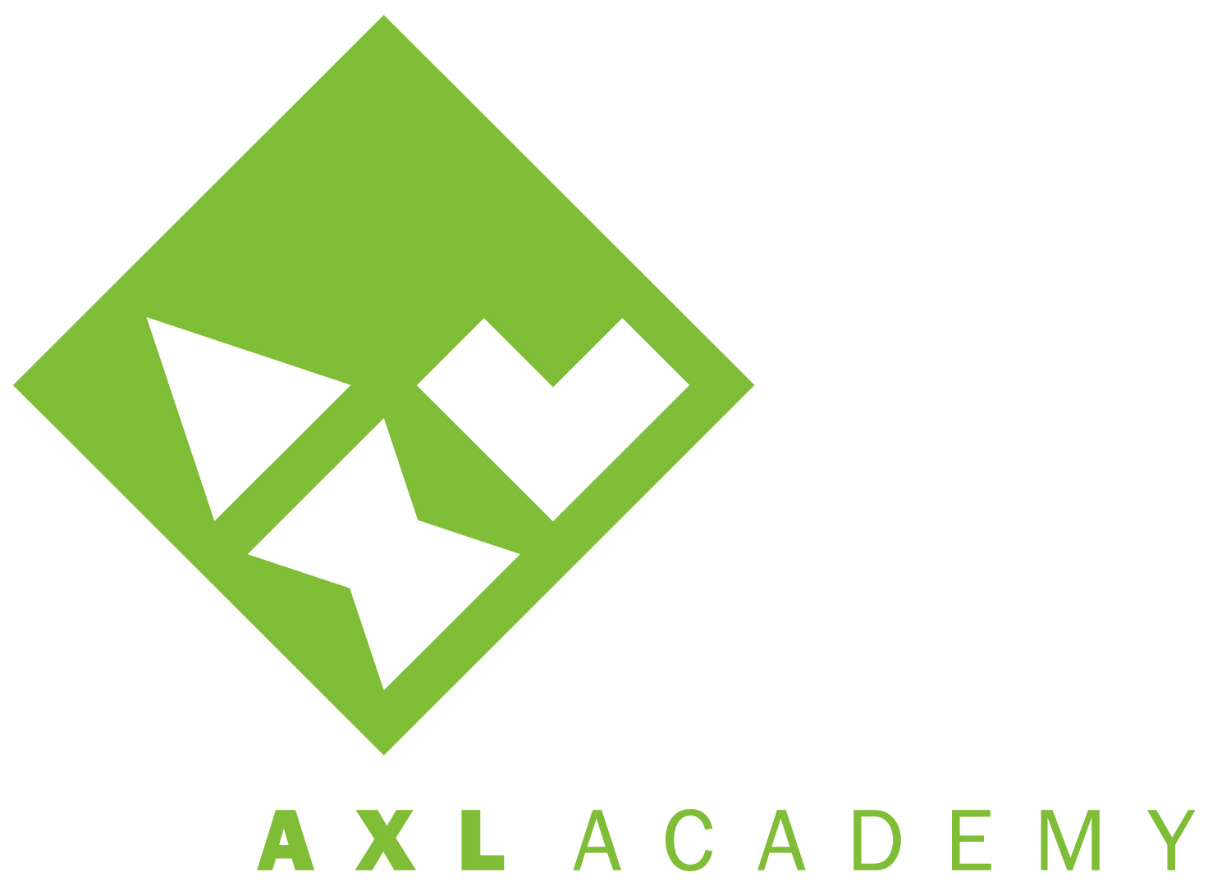
BOARD OF DIRECTORS AGENDA
Friday, August 16, 2013
10:30am – 12:30pm
AXL Academy

- Preliminary (5 min)
- Roll Call/Declaration of Quorum
- Approval of Agenda
- Approval of Minutes
- Public Comment

- Business Agenda
- YE Financial Reports
- Audit Update
- Enrollment
- Actuals v FY14 Operating Budget

- Discussion
- Induction & School Opening
- Enrollment & Staffing
- Fundraising Plan: Director of Development Hired!
- Board Recruitment & Transition: 4 New Members!
- Head of School Performance Targets: Draft for Review

- Adjournment

Next Meeting: September 20, 2013
10:30am – 12:30am
At AXL Academy

